1. Project Planning & Management
• Project Proposal – Overview of the project, objectives, and scope
Project Title: Integrated Sports Club Management System ( FitCore )
Overview:
This project aims to develop a full-featured web-based management system for sports clubs (gyms, academies, or sports centers). The system streamlines daily operations including membership registration, subscription plans, trainer scheduling, class bookings, attendance tracking, payments, inventory management, and access control via QR codes. It provides separate dashboards for members, reception staff, and administrators with role-based access control.
Objectives:
- Digitize and automate club management processes.
- Provide a seamless check-in experience using QR code technology.
- Enable online payments, wallet system, and invoice generation.
- Offer real-time analytics and reports for data-driven decisions.
- Ensure secure, role-based access for different user types (Owner, Admin, Receptionist, Member).
- Maintain an audit trail of all critical actions.
Scope:
The system covers:
- Member management (registration, profiles, subscriptions).
- Trainer and class management.
- Booking and attendance tracking.
- Payment processing and internal wallet.
- Inventory and low-stock alerts.
- Admin dashboard with charts and reports.
- QR code check-in with validation.
- Notification system (push, email, SMS).
- Audit trail and role-based permissions.
- Reception dashboard for quick actions.
The project will be delivered as a fully functional web application using .NET Core MVC, SQL Server, Bootstrap, and Chart.js.

• Project Plan – Timeline (Gantt chart), milestones, deliverables, and resource allocation
Timeline (estimated 12 weeks):
Phase | Activities | Duration | Milestone
1 | Requirements gathering, stakeholder analysis, user stories | Week 1 | Requirements Document
2 | System design, database schema, wireframes | Week 2 | Design Document
3 | Frontend development (HTML/CSS/Bootstrap) | Weeks 3-4 | UI Prototype
4 | Backend development (Models, Controllers, Services) | Weeks 5-7 | Core Functionality
5 | Integration of QR scanner, Chart.js, notifications | Week 8 | Feature Completion
6 | Testing (unit, integration, user acceptance) | Weeks 9-10 | Test Report
7 | Deployment, documentation, training | Week 11 | Deployed System
8 | Final presentation and grading | Week 12 | Final Submission
Gantt chart (text representation):
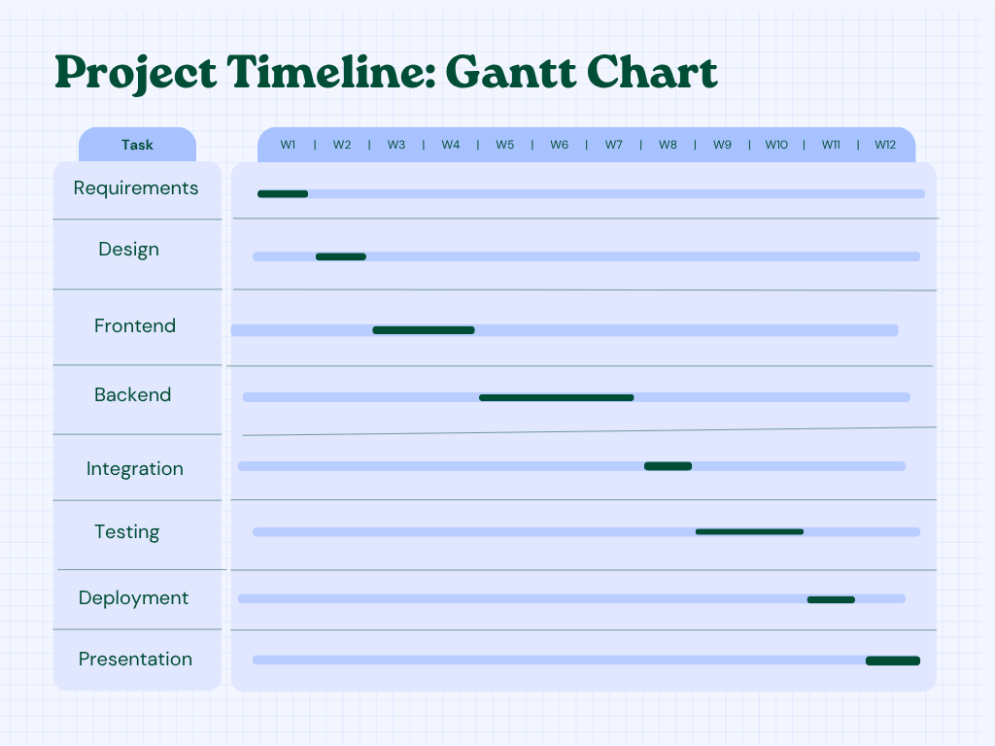
Milestones & Deliverables:
Milestone | Deliverable
Requirements approved | Requirements Document
Design completed | Database schema, UI mockups
Frontend completed | All pages linked
Backend completed | Working .NET Core MVC app
Testing passed | Test cases, bug reports
Deployment done | Live URL ( GitHub )
Final submission | Source code, documentation, presentation

Task Assignment & Roles
Name | Responsibility
Youssef Hamdy - "Team Leader" | - Write Project Proposal & Project Plan  - Write Risk Assessment & Mitigation Plan  - ER Diagram & Schema  - Check-in and attendance Module  - Dashboard Module
Rewan Mohamed | - DFD  - Functional & Non- Functional Requirements  - Stakeholder Analysis  - Alerts system & send notifications module  - Membership & Booking Management Module (Receptionist)
Rawda Mohamed | - Sequence Diagram  - Class & Private Sessions Management Module  - Trainers Management Module
Sara Mahmoud | - Use Case Diagram & Descriptions  - Authentication and Authorization module  - Role-Based Module
Aya Mohamed | - Class Diagram  - Software Architecture  - User Stories & Use Cases  - Membership & Booking Management Module (Member)  - Product Management Module  - Payment Module
Ahmed Ashraf | - Activity Diagram  - Subscriptions plans Module  - Payment and invoices Module

• Risk Assessment & Mitigation Plan – Identifying risks and solutions
Risk ID | Risk Description | Impact | Mitigation Strategy
R1 | Scope creep (adding features not originally planned) | High | Freeze requirements after sign-off; use a change request process.
R2 | Delay in frontend development | Medium | Use a component library (Bootstrap, pre-built templates); prioritize core pages.
R3 | Integration issues with QR scanner library | Medium | Test library early; have fallback manual entry.
R4 | Database performance issues with large data | Medium | Index tables; optimize queries; use pagination.
R5 | Security vulnerabilities (SQL injection, XSS) | High | Use parameterized queries (Entity Framework); validate inputs; use HTTPS.
R6 | Team member absence | High | Cross-train members; document code; have backup plan.
R7 | Browser compatibility issues | Low | Test on Chrome, Firefox, Edge; use responsive design.
R8 | Late deployment due to hosting issues | Medium | Set up hosting (GitHub) early; test deployment regularly.
R9 | User adoption resistance | Medium | Provide training videos; simple UI; support during rollout.
R10 | Data loss or corruption | High | Regular backups; use transactions; implement soft deletes.

Contingency Actions:
- For high-impact risks: allocate 15% of timeline buffer.
- Weekly risk review meeting.
- Maintain a risk log.

